A Practical Guide to Emergency Preparedness
March 20, 2022

Table of Contents

Table of Contents 1
Introduction 5
How to use this Guide 6
Spiritual Preparedness 7
Personal Revelation 7
Priesthood Blessings 7
Family Study and Unity 7
Water 8
Short-Term Storage (5 Gallon Containers) 8
Solution A (Killians) 8
Solution B (Paulsons) 8
Long-Term Storage (Large Tanks) 9
Solution A (Killians) 9
Solution B (Gundersens) 9
Water Treatment Options 9
Filters 9
Solution A (Gundersens) 9
Tablets 10
Bleach 10
Other 10
Water for Flushing Toilets 10
Online Resources 10
Food 10
Pro-Tips 10
Short-Term 11
Long-Term 11
Solution A (Gundersens) 11
Solution B (Killians) 11
Food Production 11
Bread 11
Natural Yeast 11
Garden 12
Heirloom Seeds 12
Solution A (Killians) 12
Livestock 12
Chickens 13
Ducks 13
Rabbits 13
Sprouts 13
Food Preservation 13
Canning 13
Freeze Drying 13
Dehydration 13
Solution A (Killians) 13
Smoking 14
Curing 14
Cooking 14
Outdoor Cooking Ideas 14
Propane Grill 14
Solution A (Killians) 14
Solar Oven 14
Solution A 14
Apple Box Oven 14
Solution A 14
Butane Stove 14
Solution A 14
Fire 14
Charcoal Briquettes / Dutch Oven 15
Food Storage Challenge 15
Shelter 15
Solution A (Killians) 16
72-Hour Kits 17
Solution A (Killians) 17
Communication 18
FRS - Family Radio Service 18
HAM - Amateur Radio 18
HAM Certification 18
Pro-Tip 18
HAM Nets 18
HAM Radios 18
Family Emergency Plan 21
Household Emergency Plan 21
Finances 21
Personal Finance and Self-Reliance 21
Cash 21
Other Tender 22
Solution A (Killians) 22
First Aid 24
Solution A (Gundersens) 24
Heat 24
Solution A (Killians) 25
Solution B (Gundersens) 25
Home Protection 26
Security Systems 26
Solution A (Gundersens) 26
Solution B 26
Household Items 27
Over the Counter Medicines 27
Prescription Medicines 27
Power 27
Solution A (Killians) 28
Solution B 28
Connecting a Portable Generator to Your Home 29
Whole Home Generator 29
Solar Generator - Battery Backup 29
Tools 29
Transportation 31
Thoughts 31
Solution A (Killians) 31
Vehicles 31
Solution A 31
Waste Management 32
Home Toilet - Water 32
Home Toilet - No Water 32
Portable Toilets 32
Solution A (Killians) 32
Appendix A - Other Resources 33
Church of Jesus Christ 33
Emergency Preparedness 33
Food Storage 33
HAM 33
Preparedness Manuals 33
Other 33
Appendix B - Sample 72 Hour Kit Checklist 34
Appendix C - Sample Budget 35
Appendix D - Example Sourdough Starter 37
Appendix E - Utah Planting Dates 40

Introduction
We live in the latter days. Much will happen between now and when the Savior comes again. “Our Savior and Redeemer, Jesus Christ, will perform some of His mightiest works between now and when He comes again.” What an exciting time to live! With that also comes the realization that much by way of calamity will come our way between now and then. Whether it’s a disruption in the supply chain, an increase in demand for toilet paper, the loss of employment, or natural disasters, we should all be ready for whatever will be thrown at us. Most importantly If we are prepared we will be in a better position to help our brothers and sisters in the coming days.
D&C 38:30. “If Ye Are Prepared Ye Shall Not Fear”
President Ezra Taft Benson commented on this verse in one of his general conference addresses:
“What are some of the calamities for which we are to prepare? In section 29 the Lord warns us of ‘a great hailstorm sent forth to destroy the crops of the earth.’ (D&C 29:16.) In section 45 we read of ‘an overflowing scourge; for a desolating sickness shall cover the land.’ (D&C 45:31.) In section 63 the Lord declares he has ‘decreed wars upon the face of the earth. …’ (D&C 63:33.)
“In Matthew, chapter 24, we learn of ‘famines, and pestilences, and earthquakes. …’ (Matt. 24:7.) The Lord declared that these and other calamities shall occur. These particular prophecies seem not to be conditional. The Lord, with his foreknowledge, knows that they will happen. Some will come about through man’s manipulations; others through the forces of nature and nature’s God, but that they will come seems certain. Prophecy is but history in reverse—a divine disclosure of future events.
“Yet, through all of this, the Lord Jesus Christ has said: ‘… if ye are prepared ye shall not fear.’ (D&C 38:30.)
“What, then, is the Lord’s way to help us prepare for these calamities? The answer is also found in section 1 of the Doctrine and Covenants, wherein he says: [D&C 1:17–18, 37].
“Here then is the key—look to the prophets for the words of God, that will show us how to prepare for the calamities which are to come [see D&C 1:38].” (In Conference Report, Oct. 1973, p. 89; or Ensign, Jan. 1974, p. 68.)
We are all familiar with what prophets current and past have asked us to do, so let’s do it. This document contains a variety of topics that hopefully cover most of what we have been encouraged to do. Let us all do what we can to prepare both temporarily and spiritually for the days ahead.

How to use this Guide
I imagine this document will grow quite large as we all contribute to it. It is intended that this document be very practical. With that in mind if you have a “solution” that has worked for you please add it. This way all who view this guide will have many concrete examples of what others are doing, add links to products and online resources. If you want to add your name to a solution that would be great or you can add a new solution anonymously.

- If you see a blank section and have some expertise in that area add your thoughts.
- If you have something to add to a specific section please add it!
- If you feel like researching a specific topic please do, let us know what you learn!
- If you want to add a comment or question to something you're welcome to, (Insert -> Comment).

You might also consider printing out this guide, or at least the parts of it that interest you, just in case you need to reference it in the absence of the internet.

Please share this document with your friends and family. Anyone with a link to this document can view and edit it.

Hopefully we can all learn and prepare together.

Thanks,

Spencer

Spiritual Preparedness
President Nelson is has repeatedly and consistently warned us to prepare spiritually for coming spiritual challenges:

- “In coming days, it will not be possible to survive spiritually without the guiding, directing, comforting, and constant influence of the Holy Ghost.” April 2018 General Conference.

- "My dear brothers and sisters, these are the latter days. If you and I are to withstand the forthcoming perils and pressures, it is imperative that we each have a firm spiritual foundation built upon the rock of our Redeemer, Jesus Christ." April 2021 General Conference.

- “As we keep our covenants, [Jesus Christ] endows us with His healing, strengthening power. And oh, how we will need His power in the days ahead.” October 2021 General Conference.

Personal Revelation
There are many resources and talks on personal revelation. This talk from President Nelson is excellent.

Revelation for the Church, Revelation for Our Lives

Priesthood Blessings
Have consecrated oil on hand.

Priesthood Ordinance Card

Family Study and Unity
Weekly Come Follow Me discussions can be a source of spiritual growth, especially as we allow time for family members to ask questions that they may be uncomfortable asking among their peers. Parents do not need to know the answers to these questions, but these are key times to share testimonies.

Simply inviting family members to have daily scripture study and prayer can sometimes trigger the right change.

Water
Water is essential and should be top priority in the event of an emergency. The human body can only survive about 3 days without water. It is important to have a readily accessible water source. It is recommended that you store at least 1 Gallon of water per person per day for at least 1 week.

Short-Term Storage (5 Gallon Containers)
The most common cause for the need for water storage would be when your city water supply is compromised. Boil water orders and the like are quite common. In these cases it is quite convenient to have a way to have potable water in the kitchen and bathrooms.

Hot Water Heater
Toilet Tanks

Solution A (Killians)
5 Gallon Water Containers with Spigots
I have 6 of these that I keep filled with fresh water. I rotate the water every general conference. It is important that you have something you can put in your kitchen and bathrooms.

- Coleman 5 Gallon Water Carrier , Blue (https://www.amazon.com/gp/product/B00168PI4S/ref=ppx_yo_dt_b_search_asin_title?ie=UTF8&psc=1)
These are what we bought some time ago. They were only about $10.00 when we bought them so they are not a great deal right now at $26.00. But something similar to these would be a great idea.

Solution B (Paulsons)
5 Gallon “Samson Cube” (blue stackable container $12.49 at IFA, spigots sold separately for about $2) 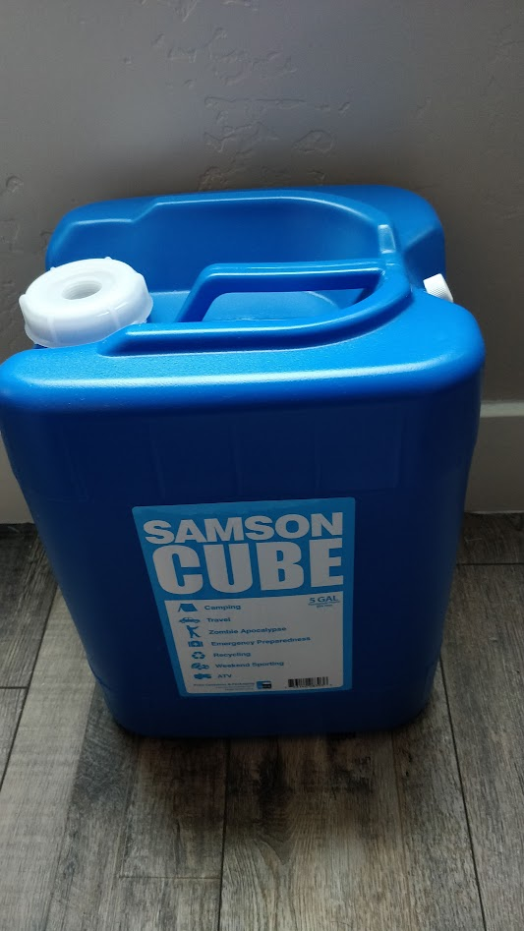

Long-Term Storage (Large Tanks)

Solution A (Killians)

The links below are what we have currently. The water treatment kits keep the water potable for 5 years. Water treated with bleach should be rotated every 1-2 years. Alternatively you can rotate the water regularly.
- 260 Gallon Emergency Water Storage Tank (Blue) – Sure Water LLC (https://www.surewatertanks.com/products/260-gallon-tank)
- 5 year Emergency Water Storage Treatment Kit – Sure Water LLC (https://www.surewatertanks.com/collections/products/products/5-year-water-treatment)
- Camco (22853) 50ft Premium Drinking Water Hose - Lead Free, Anti-Kink Design, 20% (https://www.amazon.com/gp/product/B004RNR9QY/ref=ppx_yo_dt_b_search_asin_title?ie=UTF8&psc=1)
- Thicker Than Standard Hoses (5/8"Inside Diameter) (https://www.amazon.com/gp/product/B004RNR9QY/ref=ppx_yo_dt_b_search_asin_title?ie=UTF8&psc=1)
- Hose Coupling for Tank Filling – Sure Water LLC (https://www.surewatertanks.com/collections/products/products/coupling)

Solution B (Gundersens)
BJ Plumbing Supply in Orem carries 125 gallon tanks similar to the blue one the Killians have, but are about $150 each. I have two of them. I ran a hose from the tank to the nearest drain and added a water valve for easy draining and filling. I refresh the water every year or so.

Water Treatment Options

Filters

Solution A (Gundersens)
I have used “straw water filters” like these to drink directly from rivers and lakes in the mountains. They filter out bacteria, metals, chemicals and nearly everything that can harm you, and each one can filter thousands of gallons. Any reputable brand will work fine. Membrane Solutions Straw Water Filter

- Membrane Solutions Straw Water Filter (https://smile.amazon.com/gp/product/B07T35ZXSM/ref=ppx_yo_dt_b_search_asin_image?ie=UTF8&th=1)

Tablets

Bleach
1 tsp bleach disinfects 5 gallons of water. For a 260 gallon Sure Water storage container, that is about 1 cup + 1 Tbsp of bleach.

Other

Water for Flushing Toilets
Even without running water, you can easily flush toilets by pouring a small amount of water into the toilet. Water for this purpose can come from a nearby swimming pool, irrigation canal, stream or lake. In this case, it’s helpful to have some 2-5 gallon buckets on hand, like the Homer Buckets from Home Depot

- .The Home Depot 5 Gal. Homer Bucket-05GLHD2 (https://www.homedepot.com/p/The-Home-Depot-5-Gal-Homer-Bucket-05GLHD2/100087613)

WARNING: If your home has a sump pump, you must have a power source for the sump pump in order to push that waste to the main sewer pipe and keep it from backing up and flooding your basement.

Online Resources
- Home Water Storage for an Emergency - Utah Department of Environmental Quality (https://deq.utah.gov/drinking-water/emergency-water-storage)
- Utah’s Drinking Water - Utah Department of Environmental Quality (https://deq.utah.gov/drinking-water/utahs-drinking-water)

Food
The human body can go without food for about 3 weeks.

- Food Storage (https://www.churchofjesuschrist.org/study/manual/gospel-topics/food-storage?lang=eng)

Pro-Tips
- Store what you Eat!
- Print out recipes.
- Store herbs, spices, etc to make that Long-Term food storage tasty!
- If you don’t use your food storage before it expires you can always give it away before it expires and replace it with new products.

Short-Term
Try and build up to at least 3 months.

Long-Term
Try and build up to a 1 Year supply.

Solution A (Gundersens)
We have wheat, beans, oats, and some rice. To increase the fruits and vegetables in our long-term storage we purchased cans of freeze dried fruits and vegetables that can easily be added to muffins, cereal, soups, or even eaten plain. Here is one example from Augason Farms, who sell quite a few kinds.

- Freeze Dried Sliced Strawberries (https://smile.amazon.com/gp/product/B008945XB0/ref=ppx_yo_dt_b_search_asin_image?ie=UTF8&psc=1)

Solution B (Killians)
We have found that the Cannery is an excellent way to buy long-term storage. Most of what you can buy here is sealed in air-tight #10 cans which really helps to extend the life of the food. They also come in handy boxes that are easy to stack.

- Find a Home Storage Center (https://providentliving.churchofjesuschrist.org/food-storage/home-storage-center-locations-map?lang=eng)

Food Production

Bread
If you store wheat but don’t have yeast storage, sour-dough bread starts can be quickly replicated and used to make bread with only four ingredients: flour, water, salt, and sourdough start. Here’s one recipe example. Yeast can be stored in a freezer for years, and outside of a freezer for months.

- 100% Whole Wheat Sourdough Bread - Baked (https://www.baked-theblog.com/100-whole-wheat-sourdough-bread/)

Natural Yeast
- Appendix D - Example Sourdough Starter

Sourdough Bread
Tanya Killian, Adapted from Emilie Raffa / theclevercarrot.com

Sourdough Starter:
Keep the starter in a glass jar in the fridge with a rag over it with a rubberband. Feed once every week or two. To use the starter, remove it from the fridge. Pour into a larger container like a glass batter bowl. (I like to feed it in the evening, then again in the morning, then form into bread dough that night. The longer you keep it out of the fridge and feed it, the more sour it becomes. I prefer to do 1-2 feedings before making bread dough) Combine 1 part starter, 1 part water, 1 part flour. Stir. Should be the consistency of a thick pancake batter. Put a portion back in the fridge for the next time. Place a towel over the bowl and keep it on the counter. Feed every 12ish hours. Wait about 12ish hours from last feeding to form into bread dough.

Sourdough Bread: (one loaf)
¾ cups active sourdough starter
1 cup warm water
2 Tbsp olive oil
2 tsp salt
3 ½ cups flour (add until cleaning sides of bowl, and maybe a bit more)

Mix in Bosch mixer. Turn out into a greased bowl. Spray dough with cooking spray. Cover with plastic wrap. Let raise 12ish hours, or at least overnight. Turn out onto a floured counter. Form into loaf and leave on floured counter. Let rise for about an hour, covered with a towel. Preheat oven and pan to 400 degrees F. Use a sharp knife to slash some cuts across loaf. Place in hot pan. Bake with lid on for 20 minutes. Remove lid and bake an additional 30-40 minutes. For loaves baked in clay loaf pan, I do about 35 minutes without lid. For round loaves baked in dutch oven pot, I do about 35 minutes without lid.

Garden
Appendix E - Utah Planting Dates

Heirloom Seeds
Heirloom seeds are seeds that have been passed down through generations of a plant because their produce is valued for their flavor, productivity, hardiness or adaptability. Why use heirloom seeds? Heirloom seeds can be used to grow many different types of plants, from vegetables and fruits to a large range of flowers.

You can also freeze dry your own seeds.
https://harvestright.com/blog/2016/freeze-dried-garden-seeds/

Solution A (Killians)
We purchased a variety of seeds from Amazon.com. Purchase what works best for your situation.

Livestock

Chickens

Ducks

Rabbits

Sprouts

Food Preservation
If we have to start relying on our gardens for food, are we in a position to preserve the food? Do we know how and have the supplies necessary to can our surplus food?

Canning
Ever since the COVID-19 pandemic canning supplies have either been in short supply or they are overpriced.

Freeze Drying
Freeze drying is a great way to preserve food for long term storage. Freeze dried food has a shelf life of up to 25 years if packaged correctly. It also is one of the best ways to preserve the original nutritional value of the food.

It is also one of the more expensive options. The upfront cost of purchasing a freeze drying machine makes this form of food preservation out of reach for most people.

There are a few ways to get around the high upfront cost.

- Share the cost of a machine with other people.
- Find someone who already owns a freeze drying machine and would allow you to rent time for the use of their machine.

Harvest Right is a Utah based company and is the only company that currently produces consumer grade freeze drying solutions. If you are interested in purchasing a freeze drying machine, you can see the current options available on their website. When looking to purchase, shop around. You may find a better deal at an authorized dealer.

- https://harvestright.com

Dehydration

Solution A (Killians)

- Amazon.com: Excalibur Food Dehydrator 9-Tray Electric with 26-hour Timer, Automatic Shut Off and Temperature Settings for Faster and Efficient Drying, Black: Home & Kitchen

Smoking

Curing

Cooking
What would you do if you couldn’t cook using your conventional methods?

Outdoor Cooking Ideas

Propane Grill
WARNING: Some grills run on natural gas, if that is your case then it might not work in an emergency, because the natural gas supply might be turned off.

Solution A (Killians)
We have a 3 burner camp chef and a decent supply of propane. We also use this for camping, BBQ and canning.

Solar Oven

Solution A
- Amazon.com: All American Sun Oven- The Ultimate Solar Appliance : Patio, Lawn & Garden

Apple Box Oven

Solution A
I love my apple box oven. Here are some instructions on how you could build one. I place a pie tin upside down to put the briquettes on top of it. And use wooden dowels to hold the cookie sheet.
- Cooking - Apple Box Oven (http://www.iwillprepare.com/cooking_files/Cooking_Apple_Box_Oven.htm)
- Apple Box Reflector Oven (https://theprovidentprepper.org/apple-box-reflector-oven)
- Applebox Oven: Bake in a Box! (http://prepared-housewives.com/who-needs-an-oven-use-a-box)

Butane Stove

Solution A
We have something similar to this. It came in handy when we were doing a remodel and had to cook from the garage, we used two of these and they worked great.
- Gas ONE Propane or Butane Stove (https://www.amazon.com/GS-3400P-Portable-Backpacking-Emergency-Preparedness/dp/B01HQRD8EO/ref=sr_1_3?dchild=1&keywords=butane+single+burner+stove&qid=1633995234&sr=8-3)

Fire

Charcoal Briquettes / Dutch Oven
Charcoal never goes bad and can be stored in any dry place like a shed. A volcano dutch oven portable fire pit can be used to significantly reduce the number of coals required for a meal. A charcoal chimney starter can start coals with just newspaper so you don’t need to store lighter fluid.

- Volcano Grills 3-Fuel Portable Camping Stove/Fire Pit and Storage (VL-20-300) (https://smile.amazon.com/dp/B000FDKXN6/ref=cm_sw_em_r_mt_dp_JXFVKF03NTZ7ZGVF5JZY)
- Kingsford Heavy Duty Deluxe Charcoal Chimney Starter (https://smile.amazon.com/dp/B07TM721ZS/ref=cm_sw_em_r_mt_dp_8D80YFEZGM8Y7ZKCZCNZ)

Food Storage Challenge

In 2017 a bunch of us did a “Food Storage Challenge” . You're welcome to take a look at the facebook page we created for it and what we learned. We recorded a video at the end of the challenge and talked about what we learned.

The 2017 Food Storage Challenge is over and was a great success. You can look through the posts to get some idea of how it went. You can also view the follow up meeting at this link.

- Food Storage Challenge (https://www.facebook.com/groups/1743653545899853)
- Food Storage Challenge Review (https://www.youtube.com/watch?v=QtndTBiFQZY)

Shelter
What would you do if you couldn’t sleep in your home, think of a gas leak or damage from an earthquake.

Solution A (Killians)
We have some Kodiak tents. I really like them, they hold up well in the wind and rain. The only drawback would be that you have to stake them down into the ground for them to work.

- 10 x 14 ft. Flex-Bow Canvas Tent Deluxe - Kodiak Canvas
- Ground Tarp 10 x 14 ft. - Kodiak Canvas
- Amazon.com: Mr. Heater F273699 Fuel Filter, Gray : Tools & Home Improvement
- Amazon.com : DOZYANT 12 Feet Propane Tank Converter Adapter Hose Assembly Replacement for QCC1 / Type1 LP Gas Tank with Safety Certified Connects Bulk Propane Appliances to 20 LB Propane Cylinder Tank : Patio, Lawn & Garden
- Amazon.com: Mr. Heater F232000 MH9BX Buddy 4,000-9,000-BTU Indoor-Safe Portable Propane Radiant Heater, Red-Black : Home & Kitchen
  - You can also get a bigger buddy heater
    - AmazonSmile: Mr. Heater F274800 MH18B, Portable Propane Heater,Red,Regular
  - You have to be really careful when you use something like this in a tent.
- Kidde Carbon Monoxide Detector with Digital Display & LED Lights, CO Alarm - Carbon Monoxide Detectors - Amazon.com

We also have enough cots and sleeping bags for everyone in the family. The sleeping bags work well in the winter, they might be a bit warm for the summer but you could just sleep with them unzipped.

- Disc-O-Bed XL Portable Cot Bundle | Costco
  - These are fun, but are really big, if you were to put two sets of cots in the 10X14 tent it is a tight fit!
- Amazon.com : TETON Sports Celsius XL-25F Sleeping Bag; Cold Weather Sleeping Bag; Great for Family Camping; Free Compression Sack : Teton Sports Camping : Sports & Outdoors
- Amazon.com : Klymit Static V Sleeping Pad, Lightweight, Outdoor Sleep Comfort for Backpacking, Camping, and Hiking, Inflatable Camping Mattress (Insulated and Non-Insulated), Green : Camping Air Mattresses : Sports & Outdoors

72-Hour Kits

Solution A (Killians)
We try to go through our kits every year and cycle through food and clothing. General conference is a great time to do this.

We have all of our 72-Hour Kits hanging up on hooks on the wall in the garage where we can easily take them and throw them into a vehicle. These are quite heavy and I wouldn’t want to go backpacking with them. The hope would be that we could quickly throw them into a vehicle, and drive to a safe location.

Sample 72 Hour Kit Checklist

Communication
Communication is key! If we can’t communicate we can’t help!

FRS - Family Radio Service
At a minimum it might be a good idea to have some FRS radios handy. You can pick these up just about anywhere with spare batteries.

HAM - Amateur Radio
Amateur Radio (ham radio) is a popular hobby and service that brings people, electronics and communication together. People use ham radio to talk across town, around the world, or even into space, all without the Internet or cell phones. It's fun, social, educational, and can be a lifeline during times of need.

HAM Certification
By far the best way to study for the HAM radio exam is to use HamStudy.org or preferably their companion Android or Iphone apps. I would suggest that you study for the Technician License. The app will take you through all of the questions that will be on the multiple choice exam. You can also take practice exams with the app. Once you are consistently passing the practice exams you can feel confident that you will pass the real exam.

Pro-Tip
- The exact questions and answers provided with HamStudy.org are on the final exam. Don’t feel like you have to completely understand the questions and answers, think of it more of an exercise in memorization.

Once you are ready to take the test you can find an exam session here HamStudy.org: Find an Exam Session

If you have any more questions check out HamStudy.org. You can also ask a friend who is HAM Radio certified.

HAM Nets

There are a bunch of HAM Nets regularly run by a variety of organizations Ham Radio Nets (noji.com)

A few of us in the Utah County area hold a simplex net monthly. The purpose of the NET is to make sure we all still know how to turn our radios on and to keep comfortable taking over the air.

1st Thursday of the month @ 9:00pm on 145.750 MHz

HAM Radios

There are many options for equipment. A few of us have settled on the Yaesu Brand. I own the following radios and equipment. This website is an excellent source of information for anything HAM related. Ham Radio Information (noji.com)

Solution A (Killians)

3 of us are HAM Radio Certified. We have a few radios which we can use to communicate over pretty large distances if need be. With our HAM Radios we are able to communicate with my brothers in Orem, and Riverton. Also if the Repeater system is up and running, we can even communicate with people all the way up to Idaho Falls.

- YAESU FT-2980R Transceivers Mobile 2 Meters, FT2980R (hamradio.com)
- I use this for my home base station. Along with this you will need the following
  - Antenna JPole
    - Pockrus J-pole Info (https://noji.com/hamradio/jpole.php)
  - Coax Cable, to connect the antenna to the radio
    - Coaxial Cable (40 Foot) PL-259 Male (https://www.amazon.com/gp/product/B006FATD52/ref=ppx_yo_dt_b_search_asin_title?ie=UTF8&psc=1)
  - Power Inverter (AC to DC Converter)
    - S-350-12 30 AMP (http://www.megawattpowersupplies.com)
- YAESU FT-60R Transceivers HT Dual Band 2m-70cm, FT60R (hamradio.com)
  - DIAMOND SRH77CA Antenna HT Dual Band 2m-70cm, SRH77CA (hamradio.com)
  - Amazon.com: Yaesu Standard Speaker Microphone SSM-17A Replaces MH-34B4B : Electronics
  - Amazon.com: Yaesu Original SDD-13 Cigarette Lighter Adapter 12VDC Cable w/Noise Filter : Electronics
  - Amazon.com : 2 Pack Replacement for Yaesu FNB-83 Two-Way Radio Battery and Charger Replacement (1600mAh, 7.2V, NI-MH) - Compatible with Yaesu FT-60R : Electronics
  - Amazon.com: Times Microwave so239-so238-barrel Yaesu Handheld Adapter Cable - LMR-195 SMA Male Plug to UHF Female So239 for Mobile and Base Antennas, 3ft : Times Microwave: Electronics
  - Amazon.com: Authentic Genuine Nagoya UT-72 Super Loading Coil 19-Inch Magnetic Mount (Heavy Duty) VHF/UHF (144/430Mhz) Antenna PL-259, Includes Additional SMA Adaptor for BTECH and BaoFeng Handheld Radios : Electronics

For our home base station I have the antenna mounted in the roof, you will get better performance if it is mounted outside. There are many articles on the best way to mount an antenna outside.

We have two hand held kits we keep in our cars.

If you start going down this road it would be wise to reach out to HAM for guidance and support.

Family Emergency Plan
Options:
Personal-and-Family-Emergency-Preparedness-Planning-Guide.pdf (https://www.churchofjesuschrist.org/bc/content/shared/english/life-help/Personal-and-Family-Emergency-Preparedness-Planning-Guide.pdf)

Household Emergency Plan
Resources to study and links to lots of preparedness:
https://www.ready.gov/plan

Fill out master plan:
https://www.ready.gov/sites/default/files/2021-04/family-emergency-communication-plan.pdf
Fill out one per household.
Discuss meeting places, where emergency phone numbers are, etc with family.
Make sure everyone knows where important documents are.

Make sure every family member has a mini version printed and in their car/backpack/purse, etc.:
https://www.ready.gov/sites/default/files/2021-10/family-communication-plan_fillable-card.pdf

Finances
We have been counseled time and time again to put our finances in order and to live within our means, get out of debt and save for a rainy day.

“If there is any one thing that will bring peace and contentment into the human heart, and into the family, it is to live within our means. And if there is any one thing that is grinding and discouraging and disheartening, it is to have debts and obligations that one cannot meet.”

Heber J. Grant | Gospel Standards, Salt Lake City: Improvement Era, 1941, p. 111

“Many of our people are living on the very edge of their incomes. In fact, some are living on borrowings… I urge you to be modest in your expenditures; discipline yourselves in your purchases to avoid debt to the extent possible. Pay off debt as quickly as you can, and free yourselves from bondage.”

Gordon B. Hinckley | “To the Boys and to the Men,” Liahona, Jan. 1999, 65–66; Ensign, Nov. 1998, 53–54.

Personal Finance and Self-Reliance
- Personal Finances (https://www.churchofjesuschrist.org/self-reliance/course-materials/personal-finances)

Cash
It is recommended to have a source of cash on hand. There are a few scenarios I can think of where this might come in handy. Decide what is right for you and your family and make a place to safely have a source of money at home.

- Banks are Closed
- Run on Banks
- Cash shortages at Banks
- Credit / Debit Cards are not working

Other Tender
There might come a time where other types of currency might come in handy. These are some other options to consider.

- Gold / Silver
  - Small amounts might be more useful. 1 ounce of gold is well over $1000.00 right now, it would be difficult to purchase something small. Silver, even Junk silver would likely be a better option for most.
- Utah Goldbacks
  - More info here (https://finestknown.com/modern/goldbacks-for-sale/buy-utah-goldbacks/?gclid=CjwKCAjwndCKBhAkEiwAgSDKQQNu4RurFpAoQOutkyZE94YNqWyPOVGWJ-Lgz99xyLOU4x99SIN1mhoCrl0QAvD_)
  - I don’t know anyone who has any Gold Backs but it looks interesting.
- Bartering
  - Have commodities on hand that you can use to trade for other things you need.

Solution A (Killians)

We take a pretty practical stance on finances. We follow a lot of what Dave Ramesy teaches. We have been out of debt for many years now and are eager to have the house paid off. If we can’t pay for something with cash then we don’t buy it. We have a 3-6 month emergency fund. We put away money each month for the things we need to buy. For example when the time comes to pay for our car registration then we pull out the money we have been saving for it. Unless there is an emergency and both Tanya and I are in agreement we do not pull from one savings category to pay for something else.

We have cash on hand in case there is an issue with getting money from a bank. We have a very limited supply of other types of tender that we could use to trade for goods or services if the dollar were to lose value.

We think that the most valuable asset we have in the event of an emergency is our food and household items storage. Along with this storage we also have the knowledge necessary to use the items we have stored.

- Appendix B - Sample Budget
- 2017 Sample Family Budget.xlsx

First Aid

Solution A (Gundersens)

There are a lot of very good first aid kits, some are quite expensive. At a minimum, we keep one of these kits in each car. We have a couple other more expensive kits (this large bin with 350 pieces) that are better organized and have a larger variety of options.

- First Aid Only 299 Pieces All-Purpose First Aid Emergency Kit (FAO-442) (https://smile.amazon.com/gp/product/B000069EYA/ref=ppx_yo_dt_b_search_asin_title?ie=UTF8&psc=1)
- BASICS 350 Piece Emergency First Aid Kit (https://smile.amazon.com/dp/B07XK1PFFQ/ref=cm_sw_em_r_mt_dp_11F9WKT8KKS74JJ5WYQX?_encoding=UTF8&psc=1)

Heat
How do you plan on staying warm in the winter?

Solution A (Killians)
We have a wood burning stove in our basement family room. We also have stacked about 1 cord of firewood for fuel. I get my wood from Tucker Lawn Care.

- Tucker's | Compost | Lindon, UT (https://www.tuckerlawncareinc.com)

Solution B (Gundersens)
We don’t have a wood fireplace, so I bought this Mr. Heater F274800 MH18B, Portable Propane Heater that is safe to run inside the house as long as you have a long hose that runs to a propane tank outside the house.

- Mr. Heater F274800 MH18B (https://smile.amazon.com/gp/product/B0002WRHE8/ref=ppx_yo_dt_b_search_asin_title?ie=UTF8&psc=1)

Home Protection

Security Systems

Solution A (Gundersens)

We use digital outdoor cameras so we can see what’s going on when we’re not home. These Wyze cameras are inexpensive and include the option to store video on an in-camera SD card for review later. These will fail during a power outage. These don’t actually protect the home, but they allow us to call neighbors or the police if something looks wrong.

- WYZE Cam v3 (https://smile.amazon.com/dp/B08R59YH7W/ref=cm_sw_em_r_mt_dp_8CA4DYH7QYHVTEYRV4V0)

Solution B

We use SimpliSafe with outdoor and indoor cameras, if you pay for the subscription it acts like a normal security system. If you decide to not pay for it you can still access camera footage but the videos won’t be stored. Video does not work during a power outage but the other sensors do.

- SimpliSafe Home Security Systems | Wireless Home Security | Burglar Alarms (https://simplisafe.com/)

Household Items
Consider household items as part of your food storage both short-term and long-term.

Over the Counter Medicines

Prescription Medicines

Power

Solution A (Killians)
Here is our solution and thoughts on power generation.

We wanted a way to keep our fridge and freezers going in the event of a power outage. But storing fuel is a challenge. I ended up getting a Dual Fuel Generator that can run off of propane. Propane can store for a long time. It won’t last forever but I would hopefully be able to refill the propane tanks. There was a run on propane directly following the recent earthquake in Utah. We also have a small solar generator and solar panels to charge it.

- Champion Power Equipment 3500W / 4375W Dual-Fuel Generator (https://www.samsclub.com/p/4375w-dual-fuel-gen/prod20951837?_br_psugg_q=champion+generator)
  - TREKPOWER RV Extension Cord(30A 50FT Power Cable) (https://www.amazon.com/gp/product/B07K6BZMNP/ref=ppx_yo_dt_b_search_asin_title?ie=UTF8&psc=1)
  - Generator Extension Cord (https://www.homedepot.com/p/WEN-25-ft-30-Amp-10-Gauge-SJTW-Fan-Style-10-3-Generator-Extension-Cord-Converts-L5-30R-to-Three-5-20R-Outlets-PC2525-3/308132641)
  - Pretty noisey
- 30lb Propane Tanks (https://www.homedepot.com/p/Flame-King-30-lbs-Empty-Propane-Cylinder-with-Overfill-Protection-Device-Valve-YSN301/302560758)
- Go 200 - Humless (https://www.humless.com/product/go-200)
- ROCKPALS SP002 Foldable 60W Solar Panel (https://www.amazon.com/gp/product/B079DNGBQN/ref=ppx_yo_dt_b_search_asin_title?ie=UTF8&psc=1)

This solution is sufficient power to run or fridges and freezer. We could also run some lights and possibly a space heater but not all of them at the same time. Space heaters consume a substantial amount of power.

Solution B
- Champion Power Equipment 2000-Watt Dual Fuel Portable Inverter Generator (https://www.walmart.com/ip/Champion-Power-Equipment-2000-Watt-Dual-Fuel-Portable-Inverter-Generator/797321959)
  - You can purchase two of these and link them together. Will need to make sure you have the correct cable to do that.
  - Very quiet.

Connecting a Portable Generator to Your Home

- GenerLink 30 Amp Meter Mounted Transfer Switch-MA23-N - The Home Depot (https://www.homedepot.com)
  - Consult an electrician and do more research.
- Hire an Electrician to provide a solution for you.

Whole Home Generator
You can buy a whole home generator, Costco and other locations sell them. You would need to have it professionally installed. These are setup to turn on automatically when the power shuts off, and are usually connected to natural gas.

Examples:
- Generac Home Standby Generators | Costco

Solar Generator - Battery Backup
These are pretty popular right now, there are lots of brands and solutions from large to small. Do your homework and pick something that is right for you and your budget.

Examples:
- Goal Zero (https://www.goalzero.com)
- Go 200 - Humless (https://www.humless.com/product/go-200)
- Home 30 | Whole House Battery Backup Power | Humless (https://www.humless.com/product/universal-30-85-house-battery)
- Powerwall | Tesla (https://www.tesla.com/powerwall)

Tools
Tools might come in handy to be able to cut down or clear trees and or help repair damaged structures.

- Chain Saw
- Power Drills
- Etc.

Transportation

Thoughts

Solution A (Killians)

We consider our vehicles empty at half a tank.

We have bikes for everyone and try to have supplies on hand to fix flat tires etc. If we had to go shopping without a vehicle could we easily get groceries back from the store?

This would be an extreme situation but we also have a flat bed trailer we could pile a bunch of stuff on if we needed to leave our home. We can pull it with any of our vehicles.

Vehicles

Solution A
I like to have these things on hand either in the car or stored at home.
- Antifreeze
- Oil
- Good set of hand tools
- Wire
- Tape
- Gloves

Waste Management

Home Toilet - Water
If you have sufficient water you can fill up a 5 Gallon bucket to flush your toilet.

Home Toilet - No Water
If you don’t have water to spare you can line your home toilet with a black garbage stack filled with kitty litter.

Portable Toilets

Solution A (Killians)
We have a “camp” toilet and some “chemicals” we could use, here is a link to it. We haven't used it yet 😀.
- Amazon.com: Camco 41541 Portable Travel Toilet-Designed for Camping, RV, Boating and Other Recreational Activities - 5.3 Gallon , White : Everything Else
- Amazon.com: Walex PPSGBG Porta-Pak Commercial Holding Tank Deodorizer Drop-Ins, Sunglow Scent (Pack of 50) : Automotive

Appendix A - Other Resources

Church of Jesus Christ

Emergency Preparedness

- Emergency Preparedness (https://www.churchofjesuschrist.org/study/manual/gospel-topics/emergency-preparedness?lang=eng)
- Stake and Ward Emergency Preparedness Guide (https://providentliving.churchofjesuschrist.org/emergency-preparedness-and-response/stake-ward-emergency-planning-guide?lang=eng)
- Personal-and-Family-Emergency-Preparedness-Planning-Guide.pdf (https://www.churchofjesuschrist.org/bc/content/shared/english/life-help/Personal-and-Family-Emergency-Preparedness-Planning-Guide.pdf)

Food Storage
- Home Storage Center - Provident Living (https://providentliving.churchofjesuschrist.org/food-storage/home-storage-center-locations-map?lang=eng)

HAM
- HAM Radio Information (https://noji.com/hamradio/hamradio.php)
- Ham Radio Outlet (https://www.hamradio.com)
- GigaParts - Amateur Radio (https://www.gigaparts.com)

Preparedness Manuals

- EMERGENCY PREPAREDNESS MANUAL (http://www.ldspreparedness.com/Resource-354/prepman.pdf)
- LDS_Preparedness_Manual_Complete.pdf (http://www.ldsemergencyresources.com/wp-content/uploads/2010/04/LDS_Preparedness_Manual_Complete.pdf)

Other
- Utah State University Extension | USU (https://extension.usu.edu)

Appendix B - Sample 72 Hour Kit Checklist

Information Bag:
- Small Ziploc for contents
- List of contents of 72 hr kit (this list)
- Family Emergency Info Card with contacts and photos
- Cash
- Water and gas emergency shut-off instructions
- Location of shut off wrench
- Paper/pen/pencil
- Small/large garbage bags
- Ziploc bags

First Aid Bag:
- Consecrated oil
- Pain relievers—ibuprofen, acetometaphin
- Children’s pain medication
- Waterproof matches
- Band-aids
- Gauze/gauze bandages/ace bandages
- Gauze tape
- Safety pins
- Q-tips/cotton balls
- Alcohol pads
- Latex gloves
- Anti-diarrhea medicine
- Antacid
- Thermometer
- Antibiotic ointment
- Special medications
- Burn ointment

Survival Bag:
- Pocketknife (with scissors and can opener)
- Candles/100 hr. candle
- Emergency blankets
- Emergency sleeping bag
- Hand/foot warmers
- Light sticks
- Headlamp, spare batteries in separate bag
- Whistle
- Flagging material
- Twine/rope
- Work gloves
- Hatchet
- Folding shovel
- Transistor radio and spare batteries
- 40’ nylon rope
- plastic sheeting/tarp
- tube tent
- Sewing kit
- Scout book

Food Bag:
- Water—1 gal/person/day
- Water purification tablets/ water filter / bottle
- 3 bags of food
- Protein: Chicken salad kit, beef jerky, protein bars
- Protein: Trail mix, almonds/cashews/peanuts
- Carbs: freeze dried apples, apple sauce pkts, hard candy
- Carbs: fruit leather, cereal bars, goldfish, cheese crackers

Miscellaneous:
- Book of Mormon
- Playing cards
- Paper, pen, pencil, stickers

Toiletries Bag:
- Toothbrush/toothpaste
- Comb
- Feminine hygiene supplies
- Pocket mirror
- Soap
- Toilet paper
- Hand towel
- Spare glasses/contacts
- Eye mask
- Ear plugs

Clothing:
- Change of underwear/clothes/socks/shoes
- Gloves/hat
- Waterproof jacket/poncho

Appendix C - Sample Budget
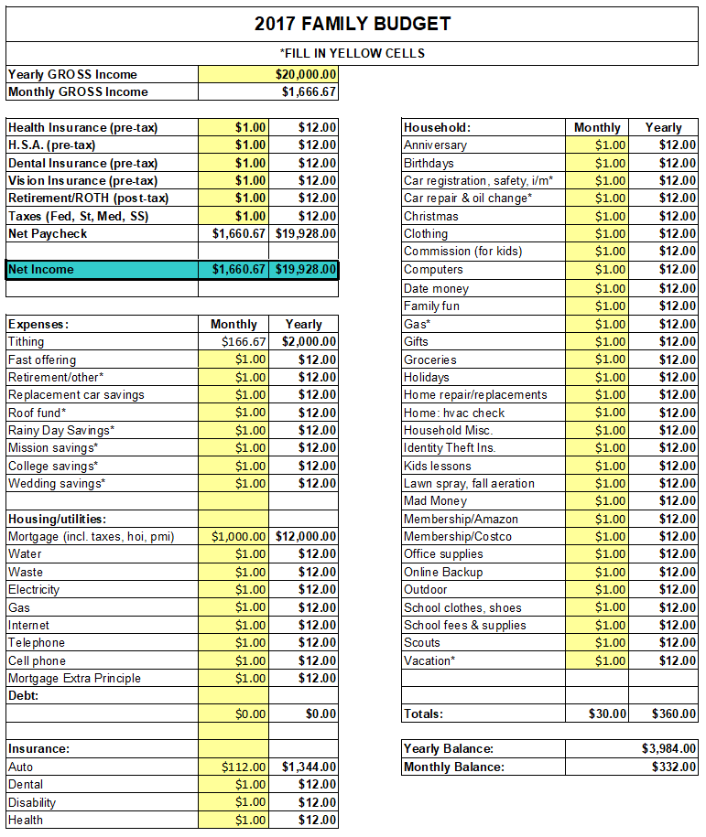


Appendix D - Example Sourdough Starter
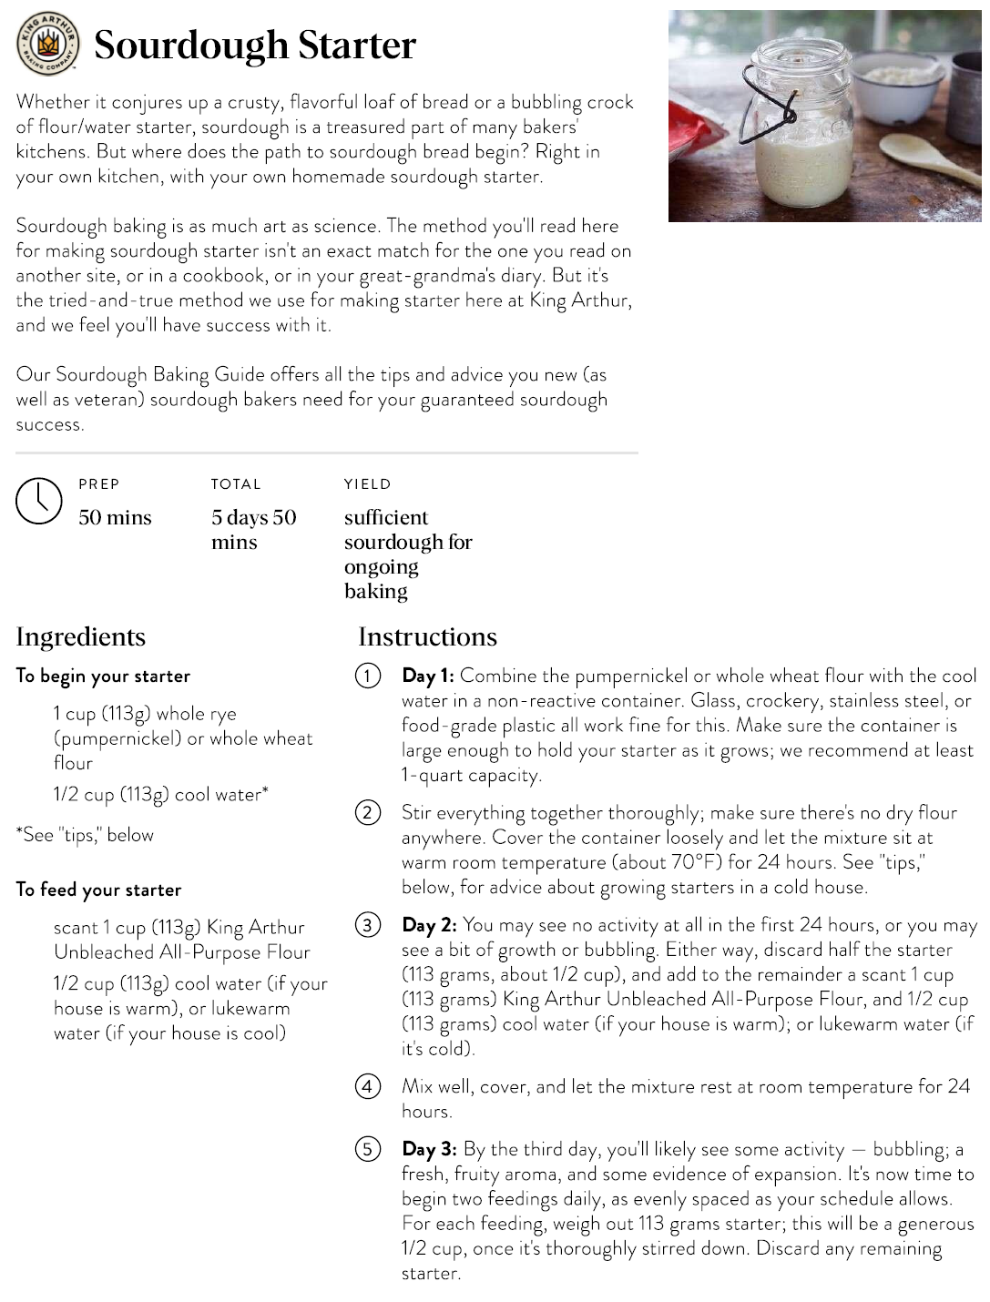
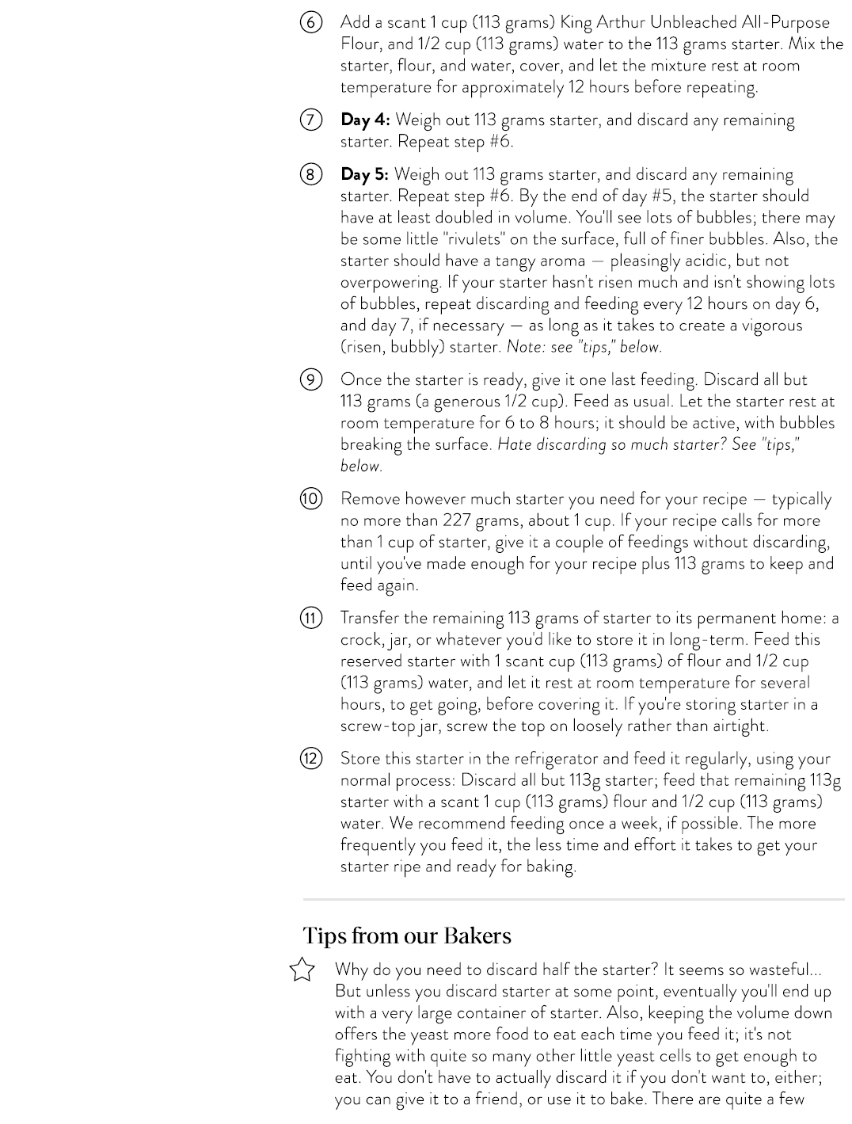
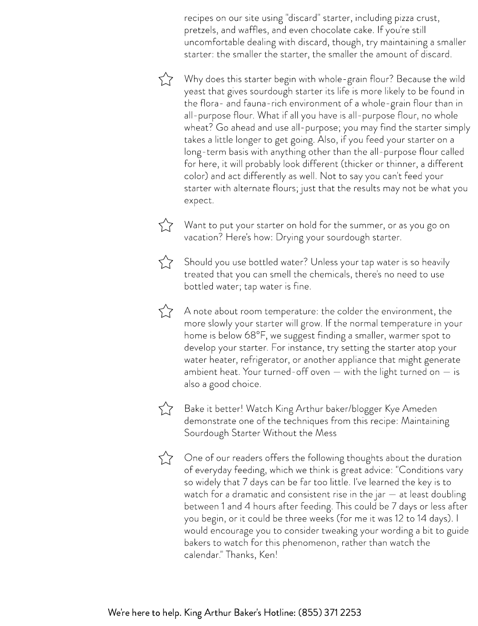
https://www.kingarthurbaking.com/recipes/sourdough-starter-recipe

Appendix E - Utah Planting Dates
https://digitalcommons.usu.edu/cgi/viewcontent.cgi?article=2843&context=extension_curall

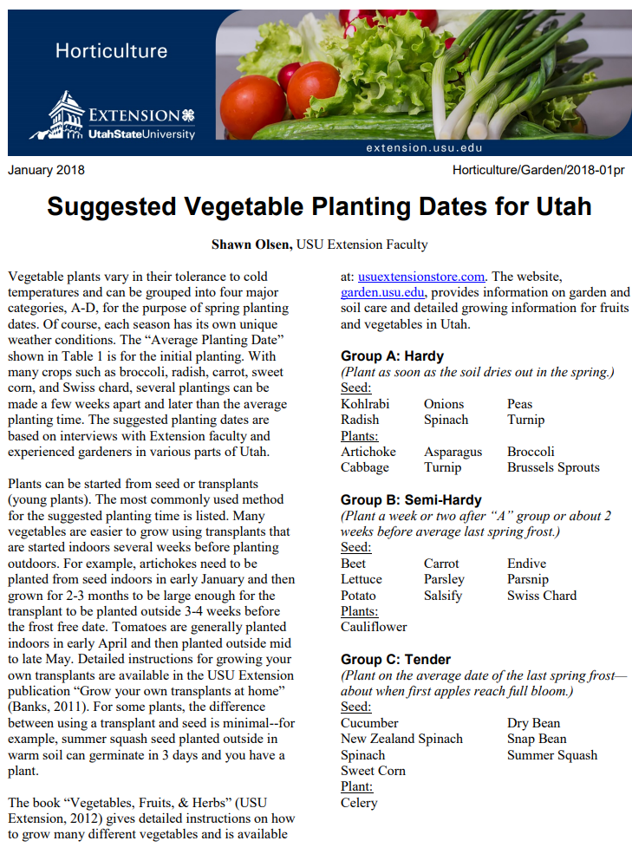
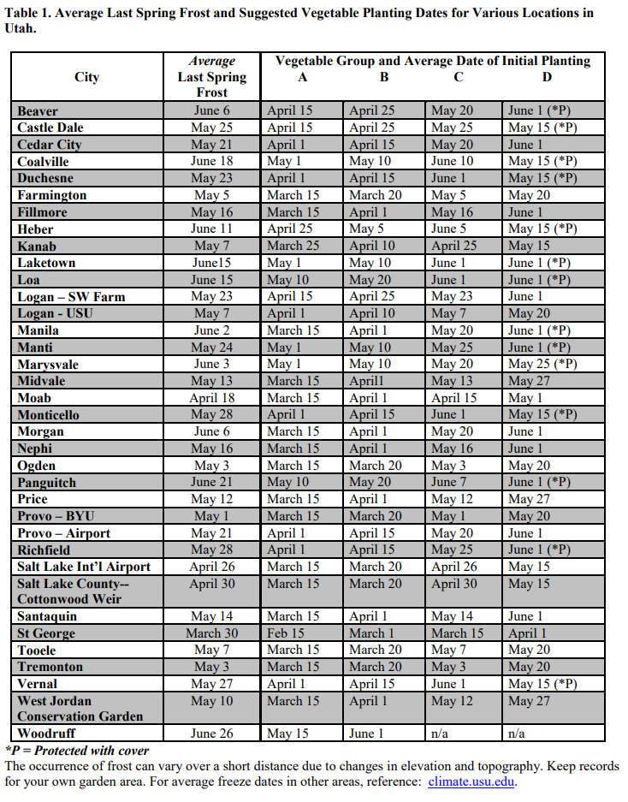
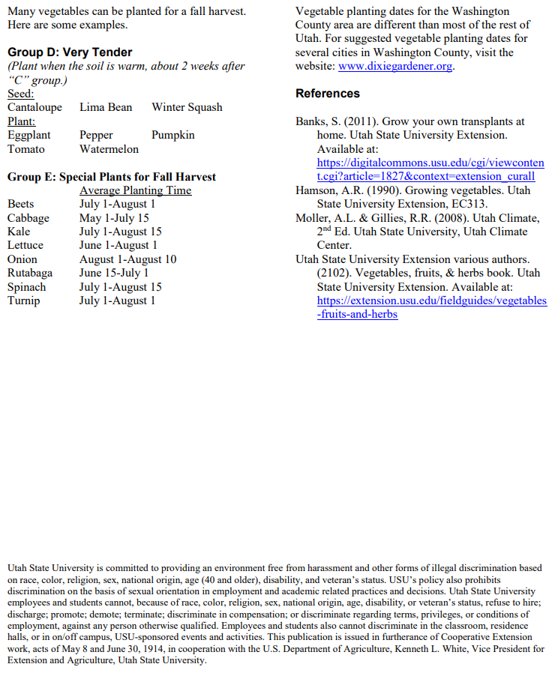

https://www.churchofjesuschrist.org/study/general-conference/2018/04/revelation-for-the-church-revelation-for-our-lives?lang=eng
https://www.churchofjesuschrist.org/manual/doctrine-and-covenants-student-manual/section-38-if-ye-are-prepared-ye-shall-not-fear?lang=eng
https://www.churchofjesuschrist.org/study/general-conference/2018/04/revelation-for-the-church-revelation-for-our-lives?lang=eng
https://www.churchofjesuschrist.org/study/general-conference/2021/10/47nelson?lang=eng
https://www.churchofjesuschrist.org/study/general-conference/2021/10/47nelson?lang=eng
Rice and Beans together make a complete protein, as described in this and other articles: https://www.healthline.com/nutrition/complete-protein-for-vegans#10.-Rice-and-beans
What Are Heirloom Seeds And Why Grow Them? - Bunnings - Bunnings Australia
What is Ham Radio (arrl.org)

